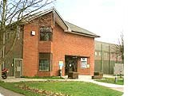

**Family and Significant Others Newsletter- March 2021**

For this month’s newsletter we wanted to give an update surrounding the Employment and Educational opportunities we have here at Guys Marsh for our residents. In line with the community guidelines surrounding easing the restrictions, this process will also begin to follow within the Prison Service- although at a slower pace. Therefore, it is important for us to get discussions started surrounding purposeful activity and how you as families, friends and loved ones can support us in encouraging our residents to get involved!

**WHAT EMPLOYMENT IS ON OFFER?**

During COVID we have only been running Essential Services employment- but in a non-COVID world, we have a number of different employment pathways that our residents can get involved with to help build on their skills, knowledge and even gain qualifications in these areas. Please see below for an overview of our employment areas:

|  |  |  |  |
| --- | --- | --- | --- |
| **Industries** | | | |
| **Area:** | **What they do:** | **Is there a Qualification?** | **Is there room for progress?** |
| **U:\MANAGER ME\Head of Reducing ReOffending\Photos\industries images\industry1.jpgFarms & Gardens** | Grow fruits and vegetables which are used in our kitchens or made available to the general public which are grown in Polytunnels and Greenhouses. This includes planting seeds and growing plants around the grounds- which is key for the summer time!  **The Qualifications- NVQ Levels 1 and 2 In Horticulture and a City & Guilds Qualification in Petrol Mowers and Strimmer’s.**  Residents can progress into a Quality Coordinator role to help with the running of the area based on skills & experience or become a Mentor to support other workers in this area. | | |
| Related image**Livestock & Project Management** | This is the opportunity to look after chickens, ducks and geese and other types of livestock. The residents are responsible for the welfare of the animals for 7 days a week.  **Residents can gain a qualification in Poultry Keeping through the Hens Trust.**  Residents can progress into a Quality Coordinator role to help with the running of the area based on skills & experience or become a Mentor to support other workers in this area. | | |
| Z:\Photos\Workshops-Laundry - 13.09.18\Workshops-Laundry - 13.09.18 011.JPG**Laundry** | Residents do the washing of the prisoner’s kit, wash kitchen whites and do the laundry for an outside contract and for other areas.  **Can get a recognised qualification through the Guild of Launderers.**  Residents can progress into a Quality Coordinator role to help with the running of the area based on skills & experience or become a Mentor to support other workers in this area. | | |
| **Waste Management** | The Team will collect waste from all departments and wings on a daily basis and then this waste is then handled and disposed of in a correct and safe way.  **Residents can gain Level 1 WAMITAB Qualification in Waste & Recycling and become trained in Bailing & Compactor use.**  Residents can progress into a Quality Coordinator role to help with the running of the area based on skills & experience or become a Mentor to support other workers in this area. | | |
| P:\WORKSHOP 6\Workshop 6 Photographs\16.jpg**Workshop 6** | This workshop is responsible for all electrical work- this includes packaging components for outside companies and refurbishment of electrical appliances such as TVs and Kettles both in our establishment and others.  **Residents can complete an Electricity Awareness Course which is 5 weeks long and details the principles of Electricity & Electrical Safety.**  Residents can progress into a Quality Coordinator role to help with the running of the area based on skills & experience or become a Mentor to support other workers in this area. | | |
| **C:\Users\mqn79a\AppData\Local\Microsoft\Windows\Temporary Internet Files\Content.Outlook\M78C1VWP\industry5.jpgWorkshop 7** | Residents in this workshop are responsible for upcycling furniture and making it look brand new or redesigned so that it can be resold through a charity shop who we hold an outside contract with. Residents can use their own ideas to make the furniture look how they want and use carpentry skills to make sure it is good to use for the next owner.  **There is no accredited qualification for this workshop, but it fits into the construction pathway courses.**  Residents can progress into a Quality Coordinator role to help with the running of the area based on skills & experience or become a Mentor to support other workers in this area. | | |
| Z:\Photos\Workshops-Laundry - 13.09.18\Workshops-Laundry - 13.09.18 006.JPG**Workshop 10** | This a contract run workshop for Bulk Hardware and the residents assist with packing the bulk hardware for this company to then sell.  **This workshop gives residents the opportunity to work on their Maths and English skills and they are supported with this by the Workshop Mentor.**  Residents can progress into a Quality Coordinator role to help with the running of the area based on skills & experience or become a Mentor to support other workers in this area. | | |

**It is really important for you as Families, Friends & Significant others to play an active role in encouraging your loved ones and our residents to positively engage with the opportunities that we offer at Guys Marsh. By gaining new skills, experiences and hopefully new qualifications- they will be allowing themselves to prepare for more employment and learning opportunities on release!**

|  |  |
| --- | --- |
| **OTHER PURPOSEFUL ACTIVITY** | |
| Image result for cleaning in progress sign**Wing Work** | Each residential unit has a cleaning party made up of ‘wing workers’ who support in keeping the wing clean and decent, serving meals and assisting with the laundry on the wing.  **All wing workers are required to gain their Industrial Cleaning Qualification.** |
| Image result for kitchensat work**Kitchens** | The Kitchens are responsible for all the meals for the residents in the establishment.  **Whilst employed here they work towards a minimum Food Hygiene Qualification and progress into training for a higher level which is a 3 year licence certificate. Residents are also given the opportunity to gain a NVQ Level 2 Food Production & Cooking Qualification.**  Residents can progress to working out on ROTL in the Jailhouse Café too! |
| [Biological Hazard](http://en.wikipedia.org/wiki/Biological_hazard)**Bio-Hazard** | We currently have a Bio-Hazard Taskforce of 10 men who are responsible for cleaning up any substances that pose a threat to any residents or staff that are within the establishment- this includes blood, sick, urine etc.  **Before you are allowed on the Taskforce you need to have evidence that you have completed your Industrial Cleaning Qualification.** |
| Image result for mentoring**Reps & Mentors** | Reps at Guys Marsh support departments to provide a professional service to residents in various different areas such as Education, Industries, and Gym etc. It is one of the most trusted jobs in the prison.  Whereas Mentors help support other residents to progress and build confidence in different areas so they can take control of their own development, use their time constructively and plan positively for release.  **A Peer Mentoring Qualification either needs to be already gained or being worked towards in either one of our Peer Mentoring Courses (L2 and L3.)** |
| **Support Advisors** | The Support Advisors are present on all wings to provide support in the following areas for all residents: Safer Custody, Violence Reduction, Substance Misuse and Equalities & Diversity. They are a contact point between the residents and the above departments and highlight any issues and provide support to deal with these issues.  **There is no direct qualification for this role, but it acts as a strong progressive route to become a Mentor or a Rep.** |

**WHAT EDUCATION IS ON OFFER?**

Our Education is provided through Weston College and from 2020 through to 2021, we have reflected both the courses and employment we offer into ‘Pathways’ for residents to follow whilst there in custody to achieve an end goal. The main goal that we want to support the residents in achieving is their Functional Skills- which is their Maths and English and try to work them up to a Level 1 whilst they are with us. We also offer this option to residents who first language is not English to support them in achieving a level of English whilst with us- this is called ‘ESOL.’

**We have 6 pathways in total:**

1. **Health, Sport & Social Care**

* Level 2 Gym Instructor NVQ
* Healthy Living (in cell pack)
* First Aid (in cell pack)
* Level 2 & Level 3 Peer Mentoring

1. **Construction**

* Level 2 Maintenance Operations
* Level 2 Diploma Bricklaying
* Level 2 Forklift and Pallet Truck Operations
* Level 2 Plastering

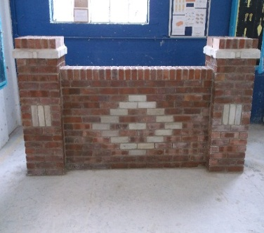

1. **Creative Arts & Trade**

* Art (in cell pack)
* Creative Art
* Therapeutic Art
* Level 2 Barbering

1. **Hospitality, Retail & Business**

* Level 1 & Level 2 Hygiene Safety in Kitchens
* Level 2 Practical Cleaning
* Cleaning (in cell pack)
* Waste & Recycling (in cell pack)
* Level 1 WAMITAB in Waste Management
* Warehousing & Storage (in cell pack)
* Level 2 Food Production & Cooking
* Level 2 Customer Service
* Guild of Launderers Qualification

1. **Science & Technology**

* Electrical Awareness Course
* Level 1 & Level 2 in ICT

1. **Animals & Agriculture**

* Level 1 & Level 2 in Horticulture
* Hens Trust Animal Care
* Mowers & Strimmer’s Qualification

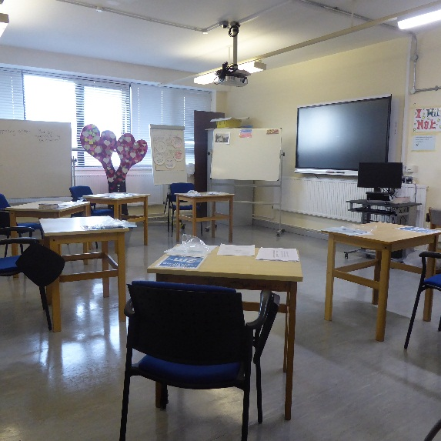

**Personal Development Courses**

These are normally requested by OMU as part of the residents Sentence Plan:

* C.L.E.A- Change Lets Everyone Achieve
* Emotional Resilience

**Distance Learning**

We have a range of different distance learning courses available through Open University or the Prison Education Trust. If any residents are interested, then they are to speak to Education or the Distance Learning Rep for more information!

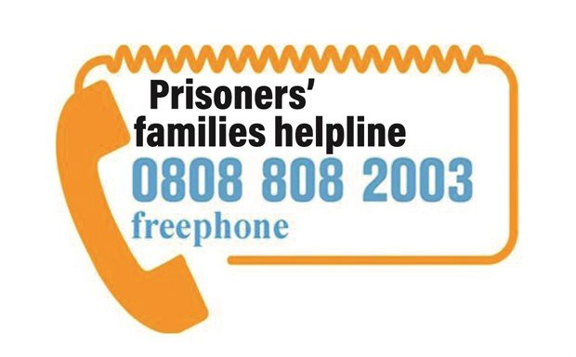

**OTHER HELPFUL INFORMATION**

* **Prisoner’s Families Helpline**: Families of prisoners can access advice and support through the Prisoner’s Families Helpline. Follow this link to watch their video for families about what to do if they have a worry or concern for a loved one in prison <https://www.prisonersfamilies.org/pages/category/need-urgent-help?Take=24>
* Children Heard and Seen support children, young people and their families who are impacted by parental imprisonment. We strive to support their needs, listen to their concerns and ensure that their voices are heard. If you have a child who would benefit from our support, somebody in your family can make a referral to us. We are currently able to take new referrals across England and Wales and offer online support for children and families with a parent in prison. They offer online Support groups for Parents who are worried about their partner in prison, online groups for children impacted by parental imprisonment to explore feelings and meet other children with a parent in prison and online 1:1 support for children worried about their parent in prison. If there is someone in your family that would benefit from our support, please ask them to email us at info@childrenheardandseen.co.uk or call us on 07557339258 or send a direct message to our Facebook page.

**Please also let us know what you would like to see on any future monthly newsletters- to help us in keeping you up to date with any information you would like to know!**

**Contact Us**

Should you have any concerns about one of the men in Guys Marsh you can contact the safer custody team by email [SaferCustodyGuysMarsh@justice.gov.uk](mailto:SaferCustodyGuysMarsh@justice.gov.uk) or if the matter is urgent call the main Prison switchboard (01747 856400) and the local safer custody team will be made aware of your concerns.

If you have any general queries or questions then feel free to contact the Family Champions Tracy & Mia by email on [FamilySupport.GuysMarsh@justice.gov.uk](mailto:FamilySupport.GuysMarsh@justice.gov.uk) or the Guys Marsh Banardos family worker Aimee on [Aimee.Derrick@barnardos.org.uk](mailto:Aimee.Derrick@barnardos.org.uk) / [GuysMarshVC@barnardos.org.uk](mailto:GuysMarshVC@barnardos.org.uk)

You can also receive regular updates on what is happening at HMP Guys Marsh by following the official twitter account [@HMPGuysMarsh](mailto:account.@HMPGuysmarsh)

We are aiming to provide you with updates on any changes or new initiatives on a monthly basis. If you would like to sign up to receive the newsletter each month via email, then please contact the Family Support email above and we can add you to a mailing list!

Also, if there is anything you would like to see on the monthly newsletters, then please get in contact and make us aware!

Stay safe and keep well☺

HMP Guys Marsh