HMP Doncaster

Families First Strategy

**9**





|  |  |  |
| --- | --- | --- |
| Document Details | | |
| Document Reference | Families First Strategy |
| Version | 001 |
| Issue Date | January 2023 |
| Review Date | December 2023 |
| Document Approver | Jo Ford |
| Document Author/Owner | Gill Peet |

|  |  |  |  |  |
| --- | --- | --- | --- | --- |
| Version history | | |  |  |
| **Version** | **Date** | **Reason for release/version update** | | **Issued by** |
| 001 | January 2023 | Reviewed in line with Families & Significant Others KPT | | J Ford |
|  |  |  | |  |

|  |  |  |  |
| --- | --- | --- | --- |
| Document approval | |  | |
| **Job Role** | **Name** | | **Date approved** |
| Head of Reducing Re-Offending | J Ford | | 25.01.23 |
|  |  | |  |

|  |
| --- |
| Contents |

|  |  |
| --- | --- |
| 1 Introduction | Page 2 |
| 2 Purpose/Vision & Mission Statement | Pages 3 & 4 |
| 3 How to contact & Emergency Concerns | Page 5 |
| 4 Directions & Location | Page 6 |
| 5 Welcome to HMP Doncaster | Page 7 |
| 6 Induction | Page 8 |
| 7 Visits | Page 9 |
| 8 HMP Doncaster Offers | Pages 10 & 11 |
| 9 Families First | Pages 12 & 13 |
| 10 How can I support? | Page 13 |
| 11 HMP Doncaster’s Future Plans | Page 14 & 15 |

|  |
| --- |
| Introduction |

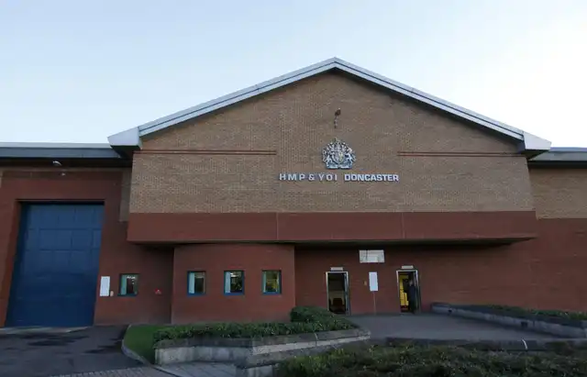

### HMP Doncaster is a category B local resettlement prison situated in South Yorkshire, operated by Serco.

HMP Doncaster houses a male population of up to 1145 individuals and most of that population comes from the local South Yorkshire area, particularly Sheffield, Doncaster, Rotherham and Barnsley. HMP Doncaster also houses approximately 200 young offenders, aged between 18-20 many of whom are from the West Yorkshire region.

As a resettlement prison we work with our prisoners, particularly those serving less than 12-months, to ensure that they have the support they need for resettlement as well as access to the services and support available to them after release. The majority of our prisoners when they are released go back into South Yorkshire.

This Families First strategy has been created encompassing the following: -

* PSO 4350 Effective Regime Interventions
* Purposeful Activity Strategy
* Operating Procedure - Rehabilitation Services – In Custody
* Prisons Strategy White Paper
* Resettlement Strategy
* Substance Misuse Strategy
* Safeguarding Strategy
* Business Plan 2022 – 2023
* HMIP Expectations – Children and families contact with the outside world (number 76 & 77)

The focus is to ensure the promotion of the importance of having healthy relationship with family and friends, providing the foundation of our moral and ethical responsibilities to assist the prisoners at HMP Doncaster in developing and/or maintaining meaningful and constructive relationships.

Prisoners at HMP Doncaster can access support throughout their sentence including the point they are preparing for their release, relating to reintegration back into family life which provides a stable platform for achieving positive change and transforming lives.

|  |
| --- |
| Purpose/Vision & Mission Statement |

A needs analysis will be carried out in January 2023, to identify prisoners who have children and will also include the number of Care Leavers, Veterans, Foreign Nationals and Young Adults.

Successful resettlement of our prisoners can only be achieved by a collaboration with internal and external partnerships.

Families First sit within the Reducing Reoffending function of HMP Doncaster, with the Head of Reducing

Re-offending as Functional Head and an identified Families First Manager.   
   
 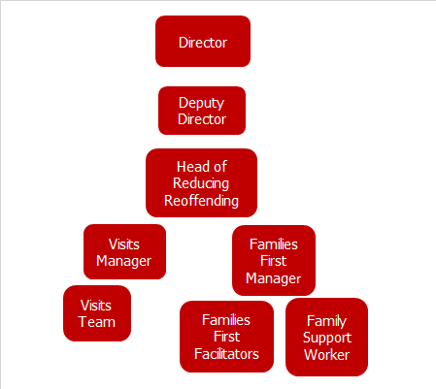

The reducing re-offending pathways and their strategies form the basis of “Giving Doncaster Purpose” and are in line with the HMIP expectations:

* Prisoners are encouraged to re-establish or maintain relationships with their children and families where it is appropriate and are supported in doing so.
* The prison supports the rights of children visiting their parent in prison, subject to a risk assessment for public protection concerns.

HMP Doncaster aims to create a positive prison experience for children and families which includes facilitating sessions to develop parenting and relationship skills. These sessions help provide meaningful support to prisoners in order that when they leave, they have the necessary skills to reintegrate back into their family and community.

Children & Families is one of the 7 pathways identified within reducing reoffending and key to our mission of “building hope and changing lives”. Families First started in 2009 with the specific aim of helping to improve outcomes for the children and families of those within our care at HMP Doncaster, placing an emphasis on building relationships and providing interventions that aim to prevent any disconnection, keeping families together. Through a variety of activities, we engage with both prisoners and their families about family values, relationships and parenting and aim to improve and maintain relationships between prisoners and their families, friends and any person in an advisory position.

As part of HMP Doncaster’s safeguarding strategy all prisoners who apply to participate in the Families First interventions are subject to a vetting process. This vetting process links in with the OMU Public Protection team to confirm suitability to access the Families First interventions and is based on any known alerts/restrictions.

Our approach to this strategy at HMP Doncaster, will remain flexible to meet the demands in change. This will be informed by continual monitoring of data through the bilat and PRM process, matching the population against our delivery and outputs. Relevant updates will be provided to prisoners, staff and visitors on progress with future development objectives and feedback from all parties.

**You asked! We did!**



|  |
| --- |
| How to contact HMP Doncaster |

#### **HMP Doncaster** Marshgate Doncaster

#### South Yorkshire

#### DN5 8UX

Tel **01302 760870**

Domestic Visits Booking Line **01302 767992** Monday – Friday 08:30 – 14:30 (You will be required to register with the prison before the prisoners are able to book you a visit)

Follow us on Twitter:

**HMP Doncaster**@HMPDoncaster

https://www.emailaprisoner and download the eMates mobile app to register an account and correspond with a prisoner via e-mail

|  |
| --- |
| Emergencies and Concerns |



At HMP Doncaster we have a dedicated 24-hour telephone line for families to contact the prison if they have any concerns about their loved one, whilst they are in custody.

**(0808 196 8814)**

The Safer Custody Team can be reached on **01302 767826** 08:30 – 17:00

There is also a dedicated e-mail address:

[Doncaster.safercustody@serco.com](mailto:Doncaster.safercustody@serco.com)

|  |
| --- |
| Directions and location |

The prison is located at Marshgate, near the centre of Doncaster and within walking distance of the train and bus stations.

Walking from the train or bus station

* From Doncaster Train Station follow the signs for the Bus Interchange, which is connected to the Train Station
* Walk through the Bus Interchange to the other end and cross the pedestrian crossing
* A small lift will take you to the road above or you can walk under the road and use the steps to take you up onto the North Bridge
* Cross the bridge and turn left following the signs to the prison

(A taxi from the bus or train station will cost approximately £5).

**If travelling by car,** the Visitors Car Park can be found on the right as you approach the prison.

### **Directions from the A1**:

* Junction 36, take the A630 Doncaster/Rotherham Road towards Doncaster and follow the signs for the town centre
* Follow signs for the railway station
* Pass the railway station on the left and go through the tunnel under the French Gate Centre
* Take the first left as you exit the tunnel over the bridge
* HMP & YOI Doncaster is signposted from there

### **Directions from the M1**:

* Junction 32, take the M18
* Exit M18 at junction 3 toward Doncaster town centre
* Follow signs for the railway station
* Pass the railway station on the left and go through the tunnel under the French Gate Centre
* Take the first left as you exit the tunnel over the bridge
* HMP & YOI Doncaster signposted

|  |
| --- |
| Welcome to HMP Doncaster |

Prisoners arriving at HMP Doncaster are initially taken to Reception and greeted by staff who will complete the booking in process. The individual will be assessed as to any concerns/vulnerability and are also offered 1 telephone call and issued a PIN number to allow them to call family and friends, once the telephone numbers have been cleared. A bedding pack is provided, which includes a quilt and pillow and bedding, a toiletry pack and a vape or sweet pack.

As part of the reception process, they are also seen by a member of the Healthcare Team. An Insider or Buddy, who is a trained prisoner, will be appointed to any individual where concerns have been raised.

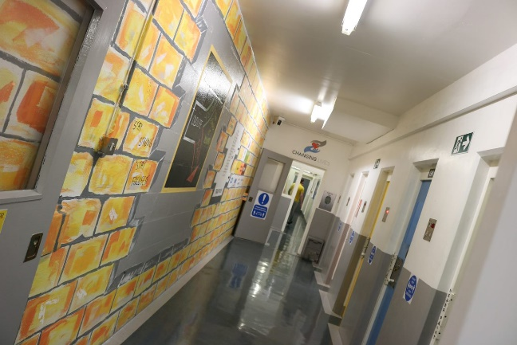 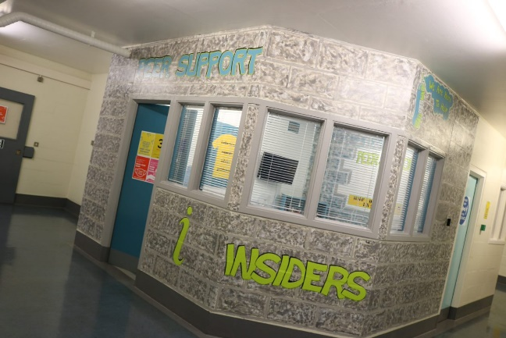

From Reception they are then taken to the Early Days Centre and allocated a bed.

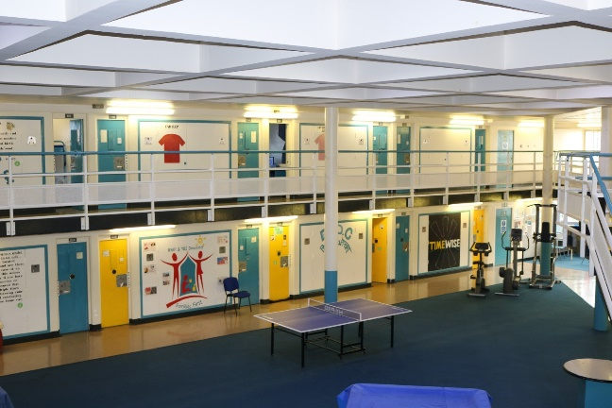

|  |
| --- |
| Induction |

On day two, after arrival into prison, prisoners attend their induction where they are assessed on their educational levels and offered support to gain the necessary level to be considered for employment whilst in custody. They are informed of all other processes within the prison including how to select their meal options, how to book a visit, how to make a complaint and how to request their telephone numbers.

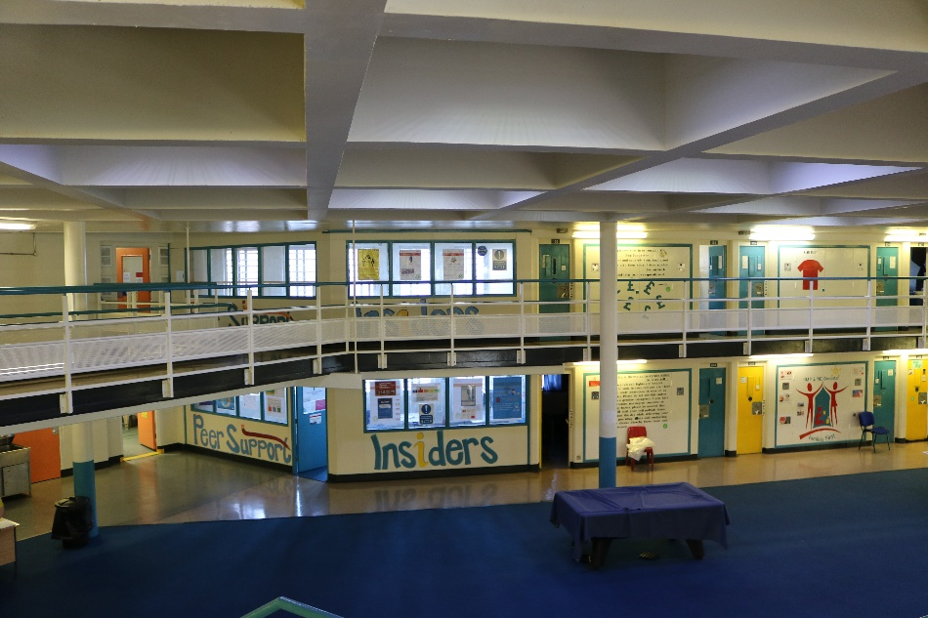

At HMP Doncaster, we have a position within the Families First team dedicated to family support. Our Family Support Worker provides a point of contact, from day 1 of arriving in custody, through to release and beyond, helping in signposting assistance/support longer term in the community.

The Family and Friends at the Centre of Throughcare scheme (FACT) enables families and friends to meet and maintain regular contact with their families and loved ones. The prison recognises the vital part relationships play in reducing reoffending and helps remove the prospects of returning to custody. In addition to upholding those strong bonds FACT informs and supports families and loved ones in an active involvement of the individual’s progress whilst at HMP Doncaster.

FACT sessions run on:

Monday 13:45 – 14:45

Friday 09:45 – 10:45

|  |
| --- |
| Visits |

HMP Doncaster operates a pre-booked visits system for Domestic Visits, which families and friends must register their details with before a visit can be booked for them.

Domestic Visits Booking Line **01302 767992** Monday – Friday 08:30 – 14:30 (You will be required to register with the prison before the prisoners are able to book you a visit)

As of 1st March 2023, the Domestic Visits sessions run:

Tuesday 09:45 – 10:45, 13:45 – 15:45 (Double session)

Wednesday 09:45 – 10:45, 13:45 – 14:45 and 15:15 – 16:15

Thursday 09:45 – 10:45 (restricted), 13:45 – 14:45 and 15:15 – 16:15

Saturday 10:00 – 11:00, 13:45 – 14:45 and 15:15 – 16:15

Sundays 10:00 – 11:00, 13:45 – 14:45 and 15:15 – 16:15 (restricted)

Visitors should arrive at the Outside Visitor Centre 30-40 minutes before their visit is due to start.

The last entry will be 15 minutes following the planned start time if visitors arrive after this entry will be denied.

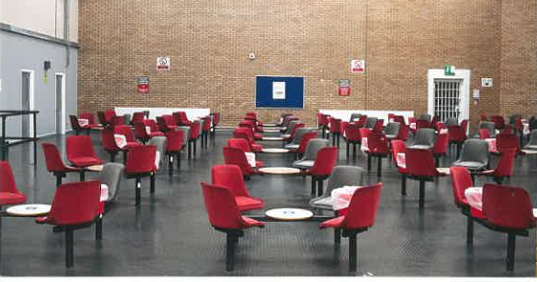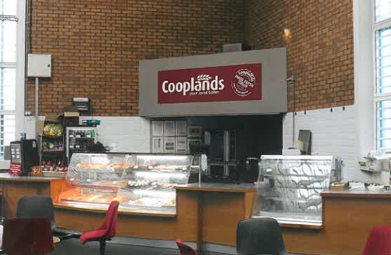

HMP Doncaster also offers families and friends the option of a secure video call by downloading the App onto a phone/laptop and registering their details to book a video call.

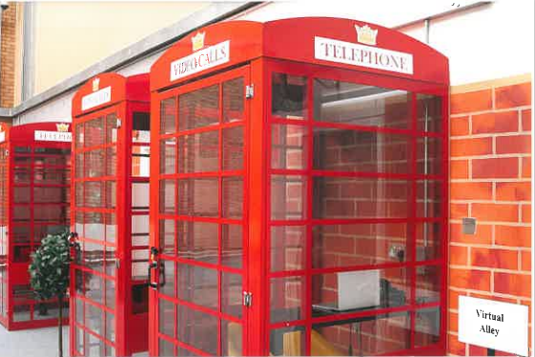

Secure 30-minute video call sessions run:

Monday and Friday from 09:30 hours throughout the day

|  |
| --- |
| What HMP Doncaster offers |

During a prisoner's time in custody at HMP Doncaster individual's will be seen and dealt with by many different members of staff ranging from the Administration Support staff, Keyworkers, Prison Custody Officers, Custodial Operations Managers, Healthcare staff including Doctors and Nurses to Prison Offender Managers, Probation Teams, Restorative Justice Team and Independent Monitoring Board members. There is a designated Equalities & Diversity Co-Ordinator and a Foreign Nationals Officer.

Whilst in custody prisoners are encouraged to attend education to improve or enhance themselves which in turn can lead to employment within the prison in the many industries offered which include:

The Textiles Unit Market Street

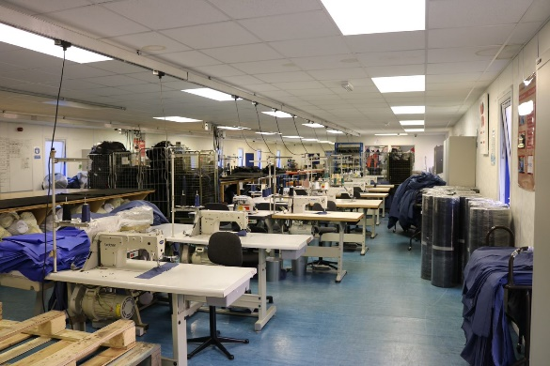 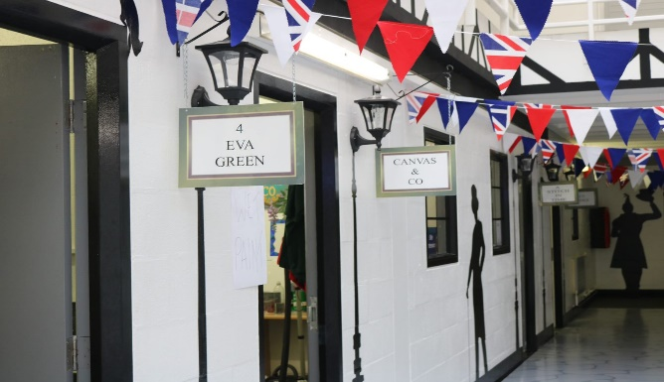

By working within the industries on offer there is also the opportunity to increase the prospect of employment on release, as qualifications can be gained.

HMP Doncaster has a fully equipped gym, with fully qualified gym instructors, which prisoners are encouraged to use to improve health, fitness and wellbeing. Regular charity events are organsied by the Gym staff which allows prisoners to raise funds for charities close to their hearts.

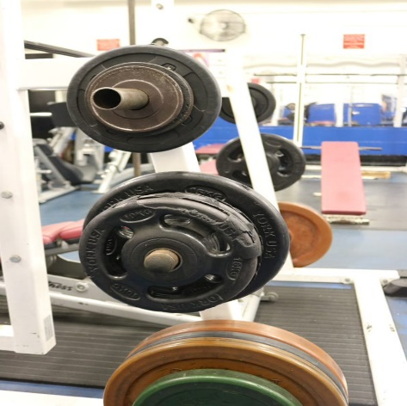 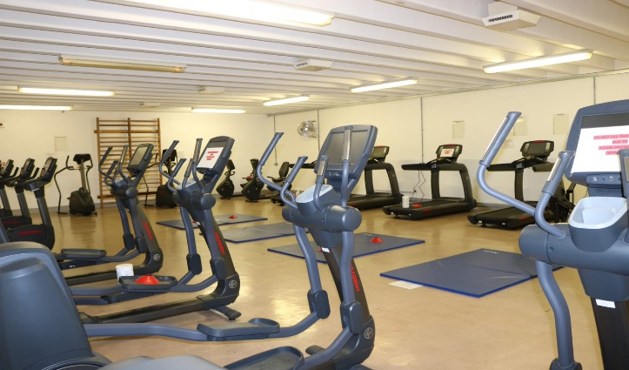

Each cell within HMP Doncaster is equipped with an in-cell telephone, for not only contacting the outside world but for internal communications. TVs are provided in-cell which allow prisoners to continue with education, outside of the usual hours and supply information about forthcoming events and regime changes. An extensive DVD library provides entertainment throughout the day and night. There is also a prison library which provides up-to-date and varied literature and includes copies of Ministry of Justice documents relating to prison rules and regulations.

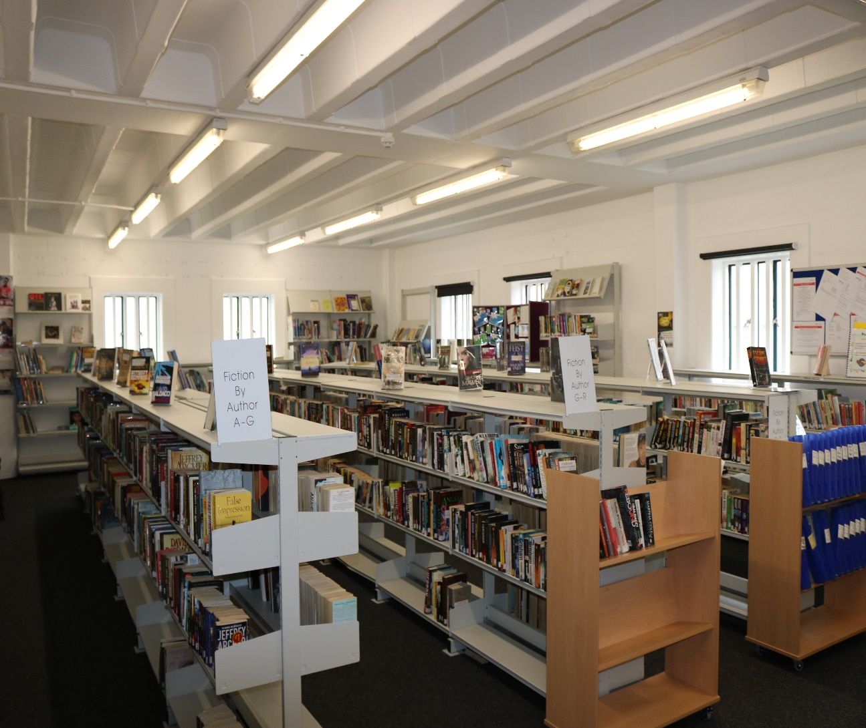

|  |
| --- |
| Families First |

Maintaining and strengthening relationships of prisoners with their families is proven to have a positive influence on the likelihood of reoffending. Prisoners’ relationships with their children are of the upmost importance, for both prisoners and children, not only through contact but with positive and meaningful interaction. At HMP Doncaster we have an extensive range of interventions embedded to maintain those crucial links and run by a dedicated Families First Team, which includes a Family Support Worker.

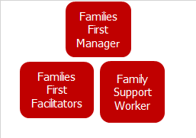

At HMP Doncaster, we recognise the value in supporting prisoners improving skills that are key to healthy relationships. Through the interventions delivered by the Families First team, these skills can raise self-esteem and confidence whilst supporting effective communication and social abilities. These interventions support prisoners positively progress through their sentence and meet their sentence planning objectives.

The interventions currently offered to prisoners include the following:

* Parenting – Providing guidance, help and support in continuing to parent their child/children whilst in custody, including one-to-one bonding sessions with their newborn child

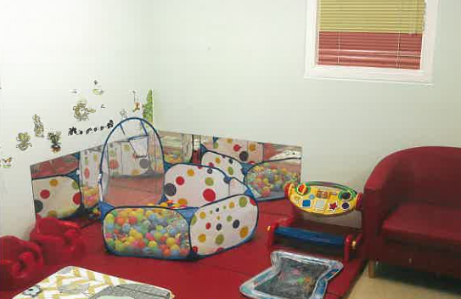

* Daddy Toddler – An intervention visit where dads and their toddlers can play games, paint and share activities
* Social Skills - Proving help and guidance on how to budget for meals, menu plan, basic cookery skills and sampling their own cooking

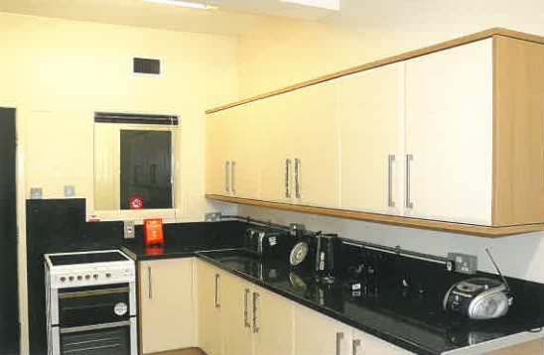

* Family Event Days – Themed days and celebrations throughout the year, where the families are encouraged to participate in the celebrations which include, Christmas, Easter, Eid, Halloween and numerous sports events
* Family Albums – This includes having photographs taken with family and friends, against seasonal backdrops and allowing the prisoners to remain part of their own family celebrations, such as birthdays, anniversaries and achievements
* Story Pack – Prisoners select a suitable book for their child which they then bring to life with puppets, pictures and personalised bag
* Treasure Box – Prisoners can record their thoughts by writing letters, making cards and gifts, which are then placed in a personalised box for either sending out to their loved ones or held in preparation for release
* Letter Box (working with external agency on this) - Depending upon restrictions letters, cards and gifts can be made and sent out to a coordinator who will store the items accordingly

These interventions help and encourage the improvement of parenting skills, including providing insights and knowledge to enable prisoners to support their children’s learning, whilst creating a positive prison experience for the family and helping to maintain strong healthy relationships.

Y

oung Adults

|  |
| --- |
| How can I support my relative/friend whilst they are in custody? |

Regular communication with family and significant others is encouraged and Family At The Centre of Throughcare (FACT) is an important insight into the individual’s journey through prison, particularly for those prisoners and their families who have never been in custody before. This scheme allows the family and significant others to be involved.

|  |
| --- |
| HMP Doncaster’s future plans |

The Families First intervention plan for 2023 is to improve the inclusivity by increasing the activities and interventions offered and this is likely to incorporate some of the following:

* Development of a small allotment area in the grounds outside the Visits Hall, where fathers and their children can plant seeds and nurture through their development.
* A cinema designated area where once a month fathers and their child/children will be able to have a ‘cinema experience’
* A full calendar of events planned for 2023, including the King’s coronation celebrations, Sporting events, Veterans Day, Remembrance Day, Christmas and other religious festivals of note, which require prisoner only attendance.

**YOUNG ADULTS**

HMP Doncaster is adopting a strategic approach for the young adults in our care alongside developing better opportunities and engagement in their journey through custody. The latest population data identifies that currently within HMP Doncaster’s population there are over 200 prisoners aged 25 and under, 23 of them being under the age of 19. The needs analysis to be completed by Families First in January 2023 will identify the number of those prisoners aged 25 and under as having children.

Families First are part of providing the cohesive drive for the specific cohort of Young Adults. Interventions available with focus around parenting and relationships aimed at the 25 year and under population. As the groups are delivered, material may be tailored to better address the specific needs of the learning from the sessions.

**CARE LEAVERS**

At HMP Doncaster, for those prisoners identified as Care Leavers further Social Skills support is offered by the Families First team which includes:

* Cleaning
* Washing
* Ironing
* Shopping on a budget

Specific forums will be held to establish needs and offer guidance/support, pre-release for everyone.

**FOREIGN NATIONALS**

At HMP Doncaster the plan for 2023 is to introduce a provision for those prisoners, who are foreign nationals and may have no family in this country but want to participate, we will look at the Families First Team providing the following interventions:

* Arts & Crafts
* Board gaming sessions
* Social kitchens
* Group/sports events
* Cinema afternoons
* Artwork promotion to family aboard

**PRISONERS WHO DO NOT RECEIVE VISITS**

Families First is an inclusive intervention and participation is promoted to all prisoner’s irrespective of their family status. There are prisoners within our establishment that do not receive any visitors during their time in custody. To service a provision to this group of prisoners, we provide the following interventions: -

* Social Skills
* Arts & Crafts
* Dominoes/Quizzes

**INCENTIVISED SUBSTANCE FREE LIVING (ISFL)**

Families First will offer on-wing interventions to support the individual's needs to maintain a substance-free lifestyle.

Along with the various ideas which HMP Doncaster has to improve the interaction for prisoners with their families and significant others we intend to conduct regular surveys throughout the year, asking not only the prisoners but also their family and significant others for any ideas and initiatives they would like to be taken forward.

**YOU ASKED! WE DID!**

